**Disciplined Entrepreneurship Workbook**

# Step 8: Quantify the Value Proposition Worksheets

### Axis to Measure Value Proposition

* 1. What is the Persona’s #1 priority?

**Avoiding non-compliance and legal errors in a rapidly changing regulatory environment.** ______________________________________________________

* 1. What units should it be measured in?  
       
     **Hours spent per week on legal research and compliance tracking, Number of compliance-related errors or missed updates, Response time to client inquiries**

### General Verbal Description of the “As Is” State and the Opportunities for Improvement

**Currently, Eleni spends 10–12 hours per week searching across multiple disconnected sources (legal databases, newsletters, and manual updates) to ensure regulatory compliance and find relevant case law. The fragmented nature of these tools causes stress, lost productivity, and sometimes missed legislative updates. Her law firm lacks a centralized, real-time legal intelligence system, making tasks repetitive and error-prone. __________________________________________________________________________________________________**

**__________________________________________________________________________________________________**

### General Verbal Description of the “Possible” State and the Opportunities for Improvement

**With the AI-driven RAG-based platform, Eleni will access real-time, consolidated legal updates and case law analysis within minutes. Time spent on research is reduced by up to 70%, and the risk of missing key updates is minimized through automated alerts and semantic search. This empowers her to focus on higher-value legal strategy and client advising._____________________________________________________________________________________________________________________________________________________________________________________________**

### Visual One-Page Summary of Quantified Value Proposition

On the page below, draw diagrams that represent the “as is” state and “possible” state, and summarize the benefits to the customer.

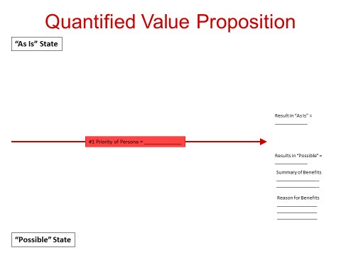

(Editable Version provided in additional Powerpoint file)